17 Relay Module

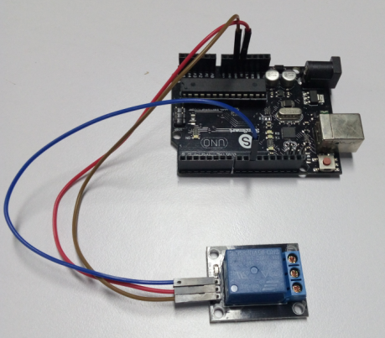

int relay = 10; // relay turns trigger signal - active high;

void setup ()

{

pinMode (relay, OUTPUT); // Define port attribute is output;

}

void loop ()

{

digitalWrite (relay, HIGH); // relay conduction;

delay (1000);

digitalWrite (relay, LOW); // relay switch is turned off;

delay (1000);

}